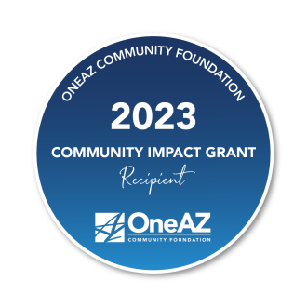
Imago Dei Middle School Receives $5,000 Grant from OneAZ Credit Union
The grant is part of OneAZ’s $330,000 Community Impact Grant Program

PHOENIX, AZ (July 6, 2023) – OneAZ Credit Union is proud to award a $5,000 Community Impact Grant to Imago Dei Middle School for their work in improving the lives of their community. Imago Dei is one of 66 nonprofit organizations that received a OneAZ Community Impact Grant.
“OneAZ is incredibly honored to award this $5,000 Community Impact Grant,” said Brandon Michaels, OneAZ President and CEO. “The organizations that the OneAZ Community Foundation supports are creating meaningful change in the communities where our members live and work. Through initiatives like the Community Impact Grant program, OneAZ is fulfilling our mission to ‘improve the lives of our members, our associates and the communities we serve.”
Imago Dei Middle School will use the funds to support the school’s programs that provide mental health counseling and therapy to students who would benefit from the support. The school has identified these programs as key to the creation of a ready-to-learn environment.
Since 2016, the OneAZ Community Foundation has provided more than $1 million in grants and funding to Arizona nonprofits through this program and other donations. Funding for the Community Impact Grant program is made possible in large part due to OneAZ members’ debit card usage. This sustainable funding model allows OneAZ to equitably distribute donation to communities where our members live and work.
To learn more about the OneAZ Community Foundation, visit OneAZcu.com/Foundation
About OneAZ Credit Union
OneAZ Credit Union is a member-owned financial institution serving more than 161,000 members and more than 10,000 businesses with 20 branch locations in Arizona. As a credit union with more than $3.3 billion in assets, OneAZ is owned by its members, who benefit from better rates, lower fees for service and improved technology. Since 1951, OneAZ has strived to help Arizonans meet their financial needs through a full suite of personal and business banking solutions. OneAZ’s mission is to truly improve the lives of its members, its associates, and the communities it serves. To learn more, visit OneAZcu.com. Insured by NCUA.

